**23-07-2024 (JAVA)**

**EX:1**

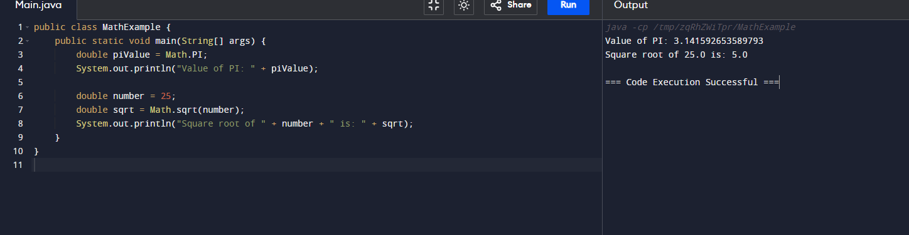

**EX:2**

**EX:3**

